EXPLORE THE WORLD WITH SHEAFE’S FLAT BLUEBIRD
Due: Friday, April 27, 2012
STUDENT NAME: ____________________________________________________ ROOM ___________
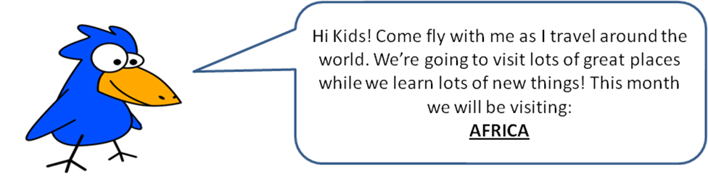
Hello, Sheafe Road students! It’s been a few weeks since I’ve corresponded with you. I heard you had Spring recess and that this week, the 3rd, 4th and 5th graders were busy taking the ELA test. I heard the Math test is coming up next week. Good luck to everyone! Last you knew, I was flying around the continent of Europe. This week, I’m flying south to the continent of Africa. Do you know anything about Africa? If not, here are some facts:
- Africa has more than fifty countries and is the second largest continent.
- The equator (the imaginary line that cuts the earth in half) goes through the middle of Africa. Land closest to the equator is very hot, while land furthest away from the equator is very cold. Because it is so hot in Africa, many people wear loose, colorful clothes that keep them cool in the hot sunshine.
- The top part of Africa is covered by the Sahara Desert. Most people live south of the desert. They also live around the coast. Much of Southern Africa is high and flat.

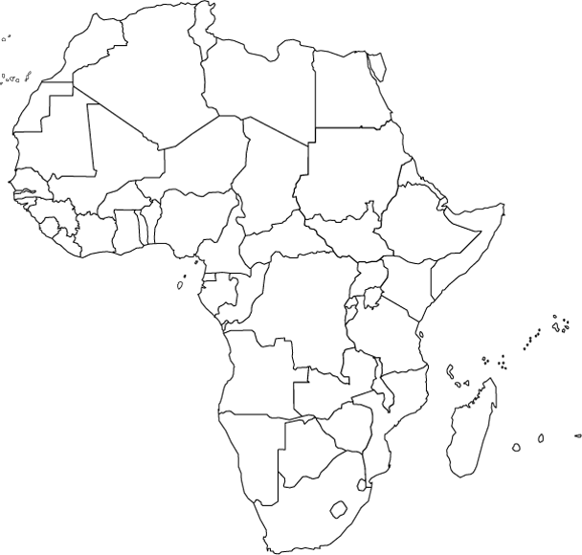

This week, we are going to find some of the countries in Africa.
Egypt is in northern Africa. It is the easternmost country in the top row. Color Egypt brown.

South Africa is at the very bottom of the continent of Africa. Color South Africa green.

Madagascar is the largest island (remember an island is a piece of land surrounded by water on all sides) off the eastern coast of the southern part of Africa. Color Madagascar red.
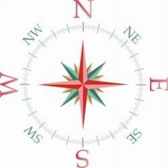

Looking for more of a challenge?
Turn the page over!

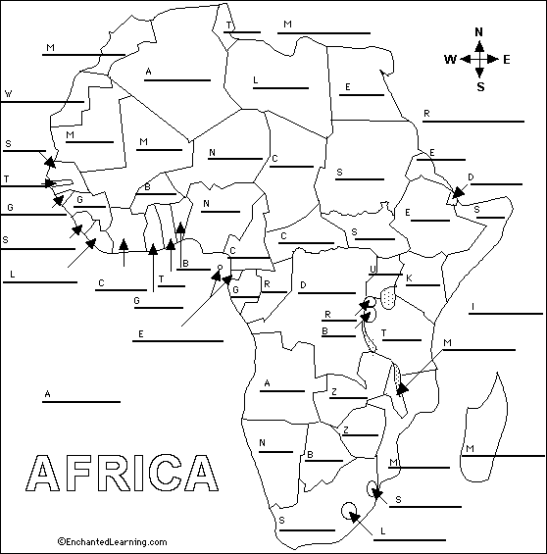

With adult permission, look at a map of Africa to locate the items on the word list below. Then, complete the above map of Africa. Good luck!

Algeria Ghana Nigeria
Angola Guinea Red Sea
Atlantic Ocean Buinea-Bissau Republic of the Congo
Benin Indian Ocean Rwanda
Botswana Kenya Senegal
Burkina Faso Sierra Leone Somalia
Burundi Lesotho South Africa
Cameroon Liberia South Sudan
Central African Republic Libya Sudan
Chad Madagascar Swaziland
Cote d”Ivoire Malawi Tanzania
Democratic Republic Mail The Gambia
of the Congo Mauritania Togo
Djibouti Mediterranean Sea Tunisia
Egypt Morocco Uganda
Equatorial Guinea Mozambique Western Sahara
Eritrea Namibia Zambia
Ethiopia Niger Zimbabwe
Gabon

